Hamilton Star SOP (08-02-2024)
Original SOP by Nicole Hewitt
Updated for new Hamilton Star by Paloma Knobloch
Table of Contents
- Logging into Systems
- Picking Compounds from Hamilton Storage Versa Q20
- Retrieving and Preparing Compounds
- Downloading Barcodes to Create PlateMap
- Uploading Worklist and PlateMap
- Primary Run Procedure
- Primary Run Timeline
- Primary Notes and Observations
- Secondary Run Procedure
- Secondary Run Timeline
- Secondary Notes and Observations
- Hamilton Storage Monthly Audit
- Notes and Non-Specific Troubleshooting
- Specific Error Troubleshooting
- Hamilton Star Layout

- Logging into Systems
  - The Robot computer password is hst
  - Verso Q20 password is 1
  - An individual IMS password is assigned for each user. It is used to log into the IMS database for scanning plate barcodes and searching compounds’ aliquot data
- Picking Compounds from Hamilton Storage Versa Q20
  - Open PDSP email
  - Open email with the Runs of the day
  - Download the Barcodes file into Download Folder
  - Click on ≡ symbol (bottom right of screen)
  - Select Run Pick Job
  - Select Import Files
  - Select the following:
    - Files: Choose desired file from Download Folder
    - Target Labware Definition: Matrix 96 blue latch racks
    - Pick Templates: Pickbycolumn
    - 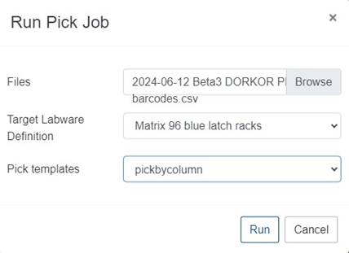
Figure 1: Run Pick Job Window
  - Click on Run
    - Note: When introducing compounds back into Versa Q20, make sure the plate’s barcode is facing out.
- Retrieving and Preparing Compounds
  - Click on No. Job Queued Folder (top menu bar)
  - Click on (square of desired compounds pick)
  - Click on Retrieve (top right menu bar)
  - Remove rack. Place lid on it and wrap it with saran wrap twice
  - Incubate compounds in water bath
    - Primary -> 30-35 minutes
    - Secondary -> 20-25 minutes
  - Remove compounds from water bath and check each one of them to assure they are not frozen and that there is enough of it in each tube. If compound level is low, refill tube
  - Weigh compounds and centrifuge them for 10 seconds
  - De-cap compounds and place them on the Robot.
    - Note: Use a new rack for the lids every time
- Downloading Barcodes to Create PlateMap
  - Click on  (pulldown menu symbol by compounds’ file name)
  - Click on Details
  - Click on Download symbol (top right of page on the blue menu bar)
  - Save file to Input Folder (check folder to assure there is no previous file in it. If there is, delete older file)
  - Click on Folder Icon symbol (taskbar on bottom of screen)
  - Double-click on Barcode_Converter Folder
  - Name file as following: “YYYYMMDD (SEC or PRIM) “ #
      - (# = number of the run of the day)
    - Note: This is the PlateMap. File is automatically saved in Output Folder.
  - Open email page
  - Attach PlateMap file from Output Folder
  - Email it to PDSP at pdsdunc@gmail.com
    - Subject of the email is the same as the PlateMap
- Uploading Worklist and PlateMap (On the Robot Computer)
  - Reboot computer at the start of each week or whenever needed
    - Note: Robot Computer Should be turned off for the weekend
  - Open emails with PlateMap and Worklist
  - Download PlateMap to OFFLINE PlateMap Folder under Hamilton Resources Drive
  - Download the Worklist to Import Worklist Folder under same drive
- Primary Run Procedure
  - Rack Set Up:
    - 50µL – 3 double racks (6 racks total) in the front 3 spaces
    - 300µL – 4 double racks (8 racks total) in the last 4 spaces
    - Primary Deck Set-Up Image:
2 -300 μL racks |  | 8 96-well plates
2 -300 μL racks |  | 8 96-well plates
2 -300 μL racks | 2 -50 μL racks | 4 96-well plates/ 4 bottom 96-well placeholder plates
2 -300 μL racks | 2 -50 μL racks
 | 2 -50 μL racks
  - Fill DI water container to the 300ml line
  - There are two places the run can be started:
    - Option A:
      - Open Hamilton Method Manager Program
      - On the Home Screen, select the Primary Icon
      - 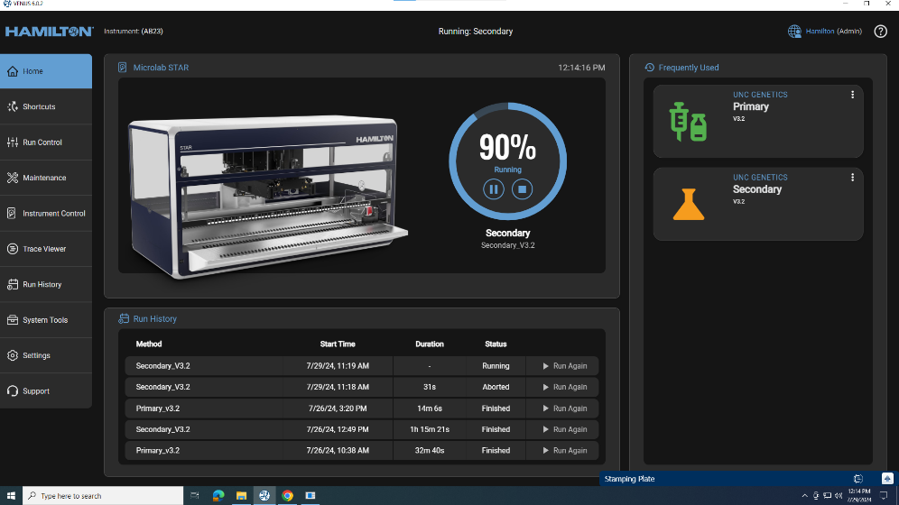
    - Option B:
      - Open the Shortcuts page
      - On the Shortcuts page, select the primary Icon
      - 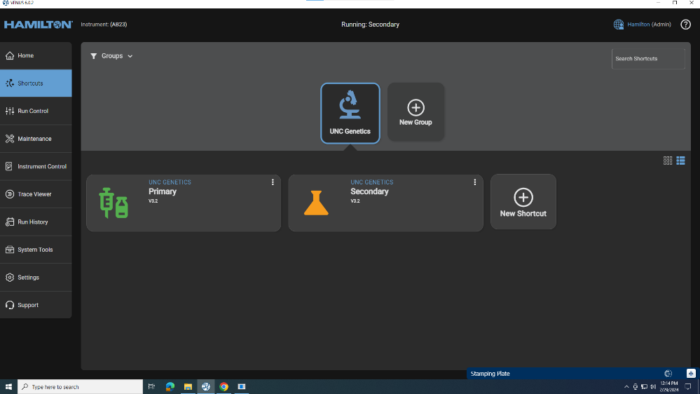
  - Select the Worklist and the Rack Map for the run
    - Rack Map: YYYYMMDD-# (from OFFLINE PlateMap Folder)
    - Worklist: YYYY-MM-DD Receptors’ names PRIM (from Import Worklist Folder)
      - For runs with two rack maps, the first Rack Map is the one with the most compounds. This should be selected first. Afterwards, the prompt will ask if a second rack map is needed for this run. Select yes, and then the option to upload the second rack map will appear. It will then be possible to input the second rack map, which is the rack map with the fewest compounds.
        - 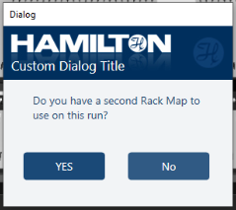
      - The second rack map is the rack map with the fewest compounds. Place the rack with the most compounds in the slot closer to the DI water and place the rack with the least compounds closer to the back of the robot.
  - Press START
  - Follow prompts for racks layout
  - Once run is over scan plates’ barcodes one by one then seal them
  - Label Sealing Sticker as follows:
PRIM MM DD
RECEPTOR ABBREVIATION - #
  - Wrap plates with saran wrap; wrap plates with the same receptor together
- Primary Run Timeline
    - Introducing Compounds: ~ 20 min
    - Picking Compounds: ~ 20-30 min
    - Run Time: ~ 1.25 hours
      - Total time: ~2-2.5 hours
- Primary Notes and Observations
  - Primary Run saves data as it finishes each plate. Plates can be scanned, sealed, and wrapped as they finish.
  - The Robot begins by adding the compounds to each plate. After all compounds are added, the robot will move the compound plate to the end of where the plates are being made.
    - A prompt will appear on screen saying the compounds are ready to be retrieved and the robot will pause for 120 seconds to allow for the compounds to be taken out.
    - The robot will resume the run after the prompt has been completed (by selecting that compounds have been retrieved) or if no option on the prompt is selected, the robot will automatically resume after 120 seconds.
      - Note: The door of robot will always remain locked, even during this pause.
      - 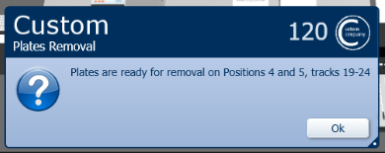
- Secondary Run Steps
  - Secondary Rack Set-Up:
    - 50µL – 3 double racks (6 racks total) in the front 3 spaces)
    - 300µL – 3 double racks and 1 single rack (9 racks total)/
      - Double racks in the first 3 spaces
      - Single rack in the last space
    - Primary Deck Set-Up Image:
1 -300 μL racks |  | 8 plates
 |  | 8 plates
2 -300 μL racks | 2 -50 μL racks | 4 top plates/ 4 bottom placeholder plates
2 -300 μL racks | 2 -50 μL racks
2 -300 μL racks | 2 -50 μL racks
    - Note: the Hamilton robot does show the last single rack of 300 μL tips that are used for DI water only, and can be reused for another run
  - Fill DI water container to the 300ml line
  - There are two places the run can be started:
    - Option A:
      - Open Hamilton Method Manager Program
      - On the Home Screen, select the Primary Icon
    - Option B:
      - Open the Shortcuts page
      - On the Shortcuts page, select the primary Icon
  - Select the Worklist and the Rack Map for the run
    - Rack Map: YYYYMMDD-# (from OFFLINE PlateMap Folder)
    - Worklist: YYYY-MM-DD Receptors’ names SEC (from Import Worklist Folder)
  - Press START
  - Follow prompts for the rack layout
  - Once run is over scan plates’ barcodes in triplicate and seal them
  - Label Sealing Sticker as follows:
    - Mother Plates:
SEC MM/DD
RECEPTOR ABBREVIATION – 0/1/2/etc.
0
    - Triplicate Plates:
SEC MM/DD
RECEPTOR ABBREVIATION - 0/1/2/etc.
(1/2/3)
  - Wrap triplicate plates of the same compound together with saran wrap
- Secondary Run Timeline
    - Introducing Compounds Time: ~ 15-20 min
    - Picking Compounds Time: ~ 15-20 min
    - Run Time: ~ 1.25 hrs for 36 compounds
      - Total Run Time: ~ 2 hours
- Secondary Notes and Observations
  - To save time, introduce Secondary compounds into Versa Q20 once Robot is done sampling them, i.e. when all mother plates are ready/robot is picking up the 300uL tips.
  - The last 300µL rack is used for DI Water only. No need to wash them. They can be re-used on another Run.
  - Data is saved at the end of stamping the triplicates.
- Hamilton Storage Monthly Audit
  - Open the Instinct Version Window on Versa Q20
  - Click on + sign (upper right of blue menu bar)
  - Select Audit Job
    - Priority: Exclusive
    - Select which columns to audit
      - Column A is where picking racks are located
      - Column B is where compounds are stored
    - Check Updated Inventory Box
    - Click Create
- Notes and Non-Specific Troubleshooting
  - Perform the Runs in the following order: SEC, PRIM, SEC, PRIM. Pick secondary compounds the day before. This will save time since Secondary compounds can be introduced into Verso Q20 while Robot is running.
  - To check barcode status during the Primary Run go to:
    - Hamilton Drive
    - OUTPUT Files STAR 96 Folder
    - Temp Folder
  - Duplicated barcodes need to be deleted.
      - Note: Only Estela can perform this task.
    - Open Folder Icon
    - Select Hamilton Drive
    - Find the Excel sheet for the specific Run
    - Plate Barcode and Worklist Lookup Table YYYY-MM-DD
      - Note: Only open the Excel sheet once Run is over for secondaries, or the run will abort. The Excel sheet can be opened during a primary run.
    - Create a copy of the Excel sheet
    - Rename it by adding today’s date at the end of its name
    - Delete the duplicate barcodes leaving only the latest ones
  - Compound location ASD and Q20 in the system are the same in the lab, which is the Hamilton Storage Versa Q20 unit.
  - Sometimes restarting Robot computer in between runs is necessary for the results to be transferred to the Versa Q20 and barcodes be scanned.
  - To save time and if only a few compounds are missing from the next barcode list, look up the missing barcodes on the current run’s Plate Map. Retrieve an empty Matrix Rack from the Verso by selecting retrieve from the Dashboard (do this instead grabbing an existing empty rack outside of the Verso to avoid filling the Verso with empty racks). Place the missing compounds on the empty matrix rack, introduce them to the Verso, then resume picking and retrieving the next run. Afterwards, introduce the remaining compounds.
  - Pause the robot only if absolutely necessary. Pausing sometimes causes the robot to abort the run that is paused.
- Specific Error Troubleshooting
  - Leading Zero Error
    - Caused by creating worklists and barcodes on different versions of Excel than the one used in lab, which causes leading zeros to be deleted. This will always result in the run being aborted. It can be somewhat rectified by deleting leading zeros in the worklist, but often causes other errors and skipped compounds/references. It is best to generate the worklist from a computer in the lab with Excel to avoid any mistakes/issues.
      - 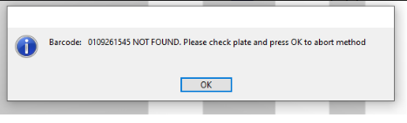
        - Barcodes will not be displayed
      - 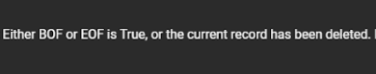
        - This occurs when there are errors with the barcodes with leading zeros at the end or beginning of a worklist.
          - Note: This should be rectified now that reference tubes all have 10-digit barcodes.
  - Liquid Level Error
    - This occurs when there is not enough of the compound/reference in the tube. It is best to just keep the robot paused, remove the compounds, and refill the tube it has errored for.
    - If the compound cannot be refilled, select the ‘Bottom’ button to make the robot reach to the bottom of the tube to pipette. This should only be done if the compound cannot be refilled. Make a note of what compound this occurred on in the worklist.
      - 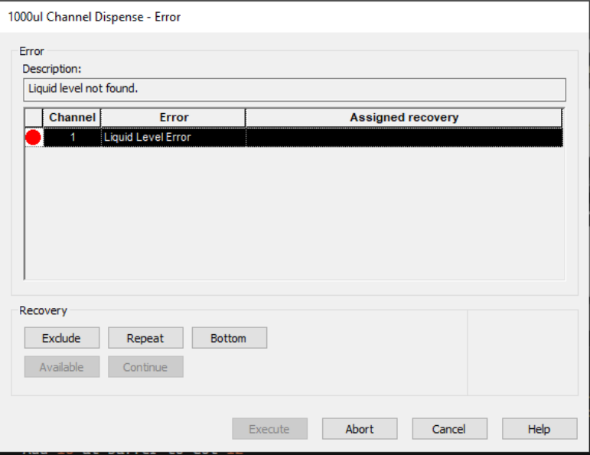
  - Communication Error to Barcode Scanner
    - Sometimes when scanning the compounds, the barcode scanner will time out and the robot will display this error message. The purpose of scanning the compounds is to make sure the rack is in the right orientation; the barcode scanner is scanning to make sure there is no barcode and thus in the right orientation. This can be rectified by repeating the command, the robot should then be able to scan the compounds and resume the run normally.
      - 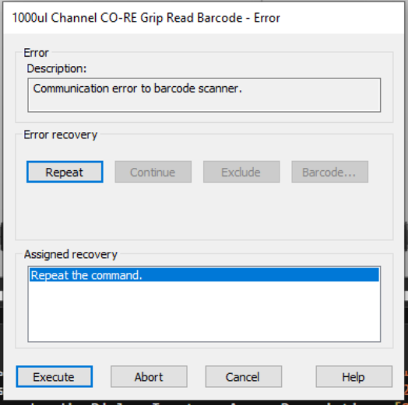
  - Auto Load Error on X Drive
    - X Drive is the barcode scanner, which can move if need be. If the barcode scanner has been pushed or stuck in a position, it will give this error. Sometimes this error is rectified by repeating the command; the run will resume normally. However, it is best to contact Hamilton if this error happens, as there is usually a problem with the belt the barcode scanner is located on. This error occurred because the belt was too tight, and needed to be loosened by Hamilton.
    - 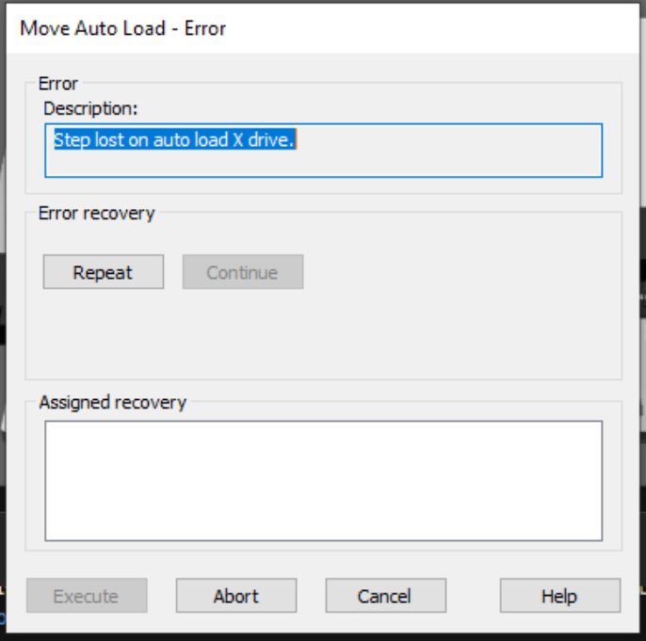
  - Z Drive Errors
    - This occurs when there are issues with the channels (this previously occurred with a rack getting caught in-between the chute and the channels that hold the plates). The channels of the robot are out of asymmetrical. To rectify, turn the robot OFF and gently move the head and channels of the robot manually to reset the machine. Turn the Robot back on and attempt the run again. If the robot still produces an error message, contact Hamilton.
      - 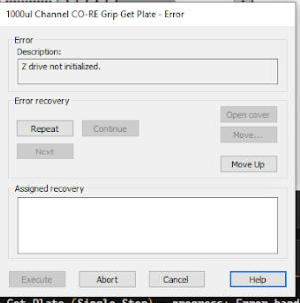
  - Syntax Error in FROM Clause
    - The wrong worklist or plate map were selected and do not match up.
      - 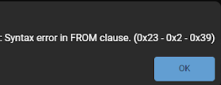
  - Database or Object is Read-Only
    - The Barcode list was open when a secondary run was attempted. Close the excel file, and the run should resume as normal.
      - Note: The Excel file can be opened during primaries, but not during a secondary run.
    - 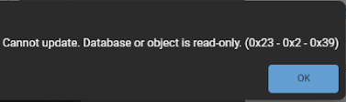
- Hamilton Star Layout
  - 